



SELÇUK ÜNİVERSİTESİ

Elektrik-Elektronik Mühendisliği

Robot Kolu Simülasyon Projesi

ÖĞRENCİLER

AD: **VEYSEL ÇOBAN**

NO:121225001

AD:**HÜSEYİN ASLANBUĞA**

NO:131225005

PROJEDEKİ AMAÇ

Bu projede yapılmak istenen solidworks de çizilen robotun matlaba atılarak gui uygulaması üzerinde bir simülasyon yapılmasıdır.Bu projede gui uygulaması butonları atayarak kol uvuzlarının oynatılması

ve simülasyon üzerinde oynatılmasıdır.

PROJENİN ŞEMASI RESİMDE GÖRÜLDÜGÜ GİBİ ;

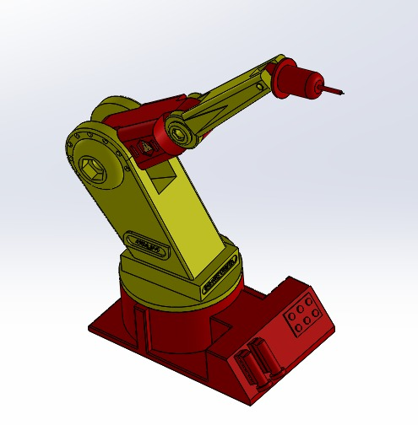

Bu çizimi matlab üzerine atarak kod yazma işlemi ve gui üzerinde uygulama aşalarına geçiyoruz.Öncelikle kodlar ;

function varargout = RRR_Robot(varargin)

% RRR_ROBOT MATLAB code for RRR_Robot.fig

% RRR_ROBOT, by itself, creates a new RRR_ROBOT or raises the existing

% singleton*.

%

% H = RRR_ROBOT returns the handle to a new RRR_ROBOT or the handle to

% the existing singleton*.

%

% RRR_ROBOT('CALLBACK',hObject,eventData,handles,...) calls the local

% function named CALLBACK in RRR_ROBOT.M with the given input arguments.

%

% RRR_ROBOT('Property','Value',...) creates a new RRR_ROBOT or raises the

% existing singleton*. Starting from the left, property value pairs are

% applied to the GUI before RRR_Robot_OpeningFcn gets called. An

% unrecognized property name or invalid value makes property application

% stop. All inputs are passed to RRR_Robot_OpeningFcn via varargin.

%

% *See GUI Options on GUIDE's Tools menu. Choose "GUI allows only one

% instance to run (singleton)".

%

% See also: GUIDE, GUIDATA, GUIHANDLES

% Edit the above text to modify the response to help RRR_Robot

% Last Modified by GUIDE v2.5 24-May-2018 02:07:27

% Begin initialization code - DO NOT EDIT

gui_Singleton = 1;

gui_State = struct('gui_Name', mfilename, ...

'gui_Singleton', gui_Singleton, ...

'gui_OpeningFcn', @RRR_Robot_OpeningFcn, ...

'gui_OutputFcn', @RRR_Robot_OutputFcn, ...

'gui_LayoutFcn', [] , ...

'gui_Callback', []);

if nargin && ischar(varargin{1})

gui_State.gui_Callback = str2func(varargin{1});

end

if nargout

[varargout{1:nargout}] = gui_mainfcn(gui_State, varargin{:});

else

gui_mainfcn(gui_State, varargin{:});

end

% End initialization code - DO NOT EDIT

% --- Executes just before RRR_Robot is made visible.

function RRR_Robot_OpeningFcn(hObject, eventdata, handles, varargin)

% This function has no output args, see OutputFcn.

% hObject handle to figure

% eventdata reserved - to be defined in a future version of MATLAB

% handles structure with handles and user data (see GUIDATA)

% varargin command line arguments to RRR_Robot (see VARARGIN)

% Choose default command line output for RRR_Robot

handles.output = hObject;

% Update handles structure

guidata(hObject, handles);

% UIWAIT makes RRR_Robot wait for user response (see UIRESUME)

% uiwait(handles.figure1);

% --- Outputs from this function are returned to the command line.

function varargout = RRR_Robot_OutputFcn(hObject, eventdata, handles)

% varargout cell array for returning output args (see VARARGOUT);

% hObject handle to figure

% eventdata reserved - to be defined in a future version of MATLAB

% handles structure with handles and user data (see GUIDATA)

% Get default command line output from handles structure

varargout{1} = handles.output;

function Theta_1_Callback(hObject, eventdata, handles)

% hObject handle to Theta_1 (see GCBO)

% eventdata reserved - to be defined in a future version of MATLAB

% handles structure with handles and user data (see GUIDATA)

% Hints: get(hObject,'String') returns contents of Theta_1 as text

% str2double(get(hObject,'String')) returns contents of Theta_1 as a double

% --- Executes during object creation, after setting all properties.

function Theta_1_CreateFcn(hObject, eventdata, handles)

% hObject handle to Theta_1 (see GCBO)

% eventdata reserved - to be defined in a future version of MATLAB

% handles empty - handles not created until after all CreateFcns called

% Hint: edit controls usually have a white background on Windows.

% See ISPC and COMPUTER.

if ispc && isequal(get(hObject,'BackgroundColor'), get(0,'defaultUicontrolBackgroundColor'))

set(hObject,'BackgroundColor','white');

end

function Theta_2_Callback(hObject, eventdata, handles)

% hObject handle to Theta_2 (see GCBO)

% eventdata reserved - to be defined in a future version of MATLAB

% handles structure with handles and user data (see GUIDATA)

% Hints: get(hObject,'String') returns contents of Theta_2 as text

% str2double(get(hObject,'String')) returns contents of Theta_2 as a double

% --- Executes during object creation, after setting all properties.

function Theta_2_CreateFcn(hObject, eventdata, handles)

% hObject handle to Theta_2 (see GCBO)

% eventdata reserved - to be defined in a future version of MATLAB

% handles empty - handles not created until after all CreateFcns called

% Hint: edit controls usually have a white background on Windows.

% See ISPC and COMPUTER.

if ispc && isequal(get(hObject,'BackgroundColor'), get(0,'defaultUicontrolBackgroundColor'))

set(hObject,'BackgroundColor','white');

end

function Theta_3_Callback(hObject, eventdata, handles)

% hObject handle to Theta_3 (see GCBO)

% eventdata reserved - to be defined in a future version of MATLAB

% handles structure with handles and user data (see GUIDATA)

% Hints: get(hObject,'String') returns contents of Theta_3 as text

% str2double(get(hObject,'String')) returns contents of Theta_3 as a double

% --- Executes during object creation, after setting all properties.

function Theta_3_CreateFcn(hObject, eventdata, handles)

% hObject handle to Theta_3 (see GCBO)

% eventdata reserved - to be defined in a future version of MATLAB

% handles empty - handles not created until after all CreateFcns called

% Hint: edit controls usually have a white background on Windows.

% See ISPC and COMPUTER.

if ispc && isequal(get(hObject,'BackgroundColor'), get(0,'defaultUicontrolBackgroundColor'))

set(hObject,'BackgroundColor','white');

end

% --- Executes on button press in btn_Forward.

function btn_Forward_Callback(hObject, eventdata, handles)

% hObject handle to btn_Forward (see GCBO)

% eventdata reserved - to be defined in a future version of MATLAB

% handles structure with handles and user data (see GUIDATA)

Th_1 = str2double(handles.Theta_1.String)*pi/180;

Th_2 = str2double(handles.Theta_2.String)*pi/180;

Th_3 = str2double(handles.Theta_3.String)*pi/180;

L_1 = 20;

L_2 = 50;

L_3 = 40;

L(1) = Link([0 L_1 0 pi/2]);

L(2) = Link([0 0 L_2 0]);

L(3) = Link([0 0 L_3 0]);

Robot = SerialLink(L);

Robot.name = 'RRR_Robot';

Robot.plot([Th_1 Th_2 Th_3]);

T = Robot.fkine([Th_1 Th_2 Th_3]);

handles.Pos_X.String = num2str(floor(T(1,4)));

handles.Pos_Y.String = num2str(floor(T(2,4)));

handles.Pos_Z.String = num2str(floor(T(3,4)));

function Pos_X_Callback(hObject, eventdata, handles)

% hObject handle to Pos_X (see GCBO)

% eventdata reserved - to be defined in a future version of MATLAB

% handles structure with handles and user data (see GUIDATA)

% Hints: get(hObject,'String') returns contents of Pos_X as text

% str2double(get(hObject,'String')) returns contents of Pos_X as a double

% --- Executes during object creation, after setting all properties.

function Pos_X_CreateFcn(hObject, eventdata, handles)

% hObject handle to Pos_X (see GCBO)

% eventdata reserved - to be defined in a future version of MATLAB

% handles empty - handles not created until after all CreateFcns called

% Hint: edit controls usually have a white background on Windows.

% See ISPC and COMPUTER.

if ispc && isequal(get(hObject,'BackgroundColor'), get(0,'defaultUicontrolBackgroundColor'))

set(hObject,'BackgroundColor','white');

end

function Pos_Y_Callback(hObject, eventdata, handles)

% hObject handle to Pos_Y (see GCBO)

% eventdata reserved - to be defined in a future version of MATLAB

% handles structure with handles and user data (see GUIDATA)

% Hints: get(hObject,'String') returns contents of Pos_Y as text

% str2double(get(hObject,'String')) returns contents of Pos_Y as a double

% --- Executes during object creation, after setting all properties.

function Pos_Y_CreateFcn(hObject, eventdata, handles)

% hObject handle to Pos_Y (see GCBO)

% eventdata reserved - to be defined in a future version of MATLAB

% handles empty - handles not created until after all CreateFcns called

% Hint: edit controls usually have a white background on Windows.

% See ISPC and COMPUTER.

if ispc && isequal(get(hObject,'BackgroundColor'), get(0,'defaultUicontrolBackgroundColor'))

set(hObject,'BackgroundColor','white');

end

function Pos_Z_Callback(hObject, eventdata, handles)

% hObject handle to Pos_Z (see GCBO)

% eventdata reserved - to be defined in a future version of MATLAB

% handles structure with handles and user data (see GUIDATA)

% Hints: get(hObject,'String') returns contents of Pos_Z as text

% str2double(get(hObject,'String')) returns contents of Pos_Z as a double

% --- Executes during object creation, after setting all properties.

function Pos_Z_CreateFcn(hObject, eventdata, handles)

% hObject handle to Pos_Z (see GCBO)

% eventdata reserved - to be defined in a future version of MATLAB

% handles empty - handles not created until after all CreateFcns called

% Hint: edit controls usually have a white background on Windows.

% See ISPC and COMPUTER.

if ispc && isequal(get(hObject,'BackgroundColor'), get(0,'defaultUicontrolBackgroundColor'))

set(hObject,'BackgroundColor','white');

end

% --- Executes on button press in btn_Inverse.

function btn_Inverse_Callback(hObject, eventdata, handles)

% hObject handle to btn_Inverse (see GCBO)

% eventdata reserved - to be defined in a future version of MATLAB

% handles structure with handles and user data (see GUIDATA)

Matlab üzerinde başlatma tuşuna basdıgımızda bir robot kolu eksenleri tasarlama ekranı çıkacak ve burda robot kollarının uzuvlarının çalışma prensiblerini ve nasıl çalıştırabildigimiz konusunda yardımcı olacak ekran çıkacak.Bkz ;

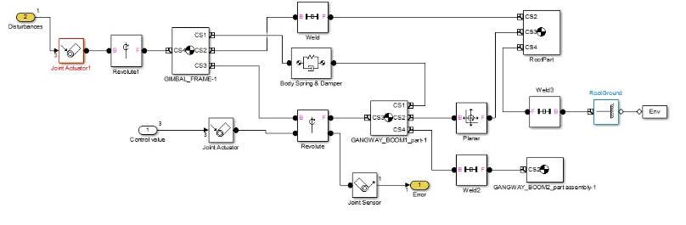

Bu aşamadan sonra da matlab gui uygulaması ile buton atamları ve robot kollarını çalıştıracagımız ve komut verecegim ayrıca uzay ekseninde x,y,z koordinatlarında rastgele verdigimiz açı değerlerinde robot kolunun gitmesini sağlayacak bir gui uygulaması tasarladık.Bkz;

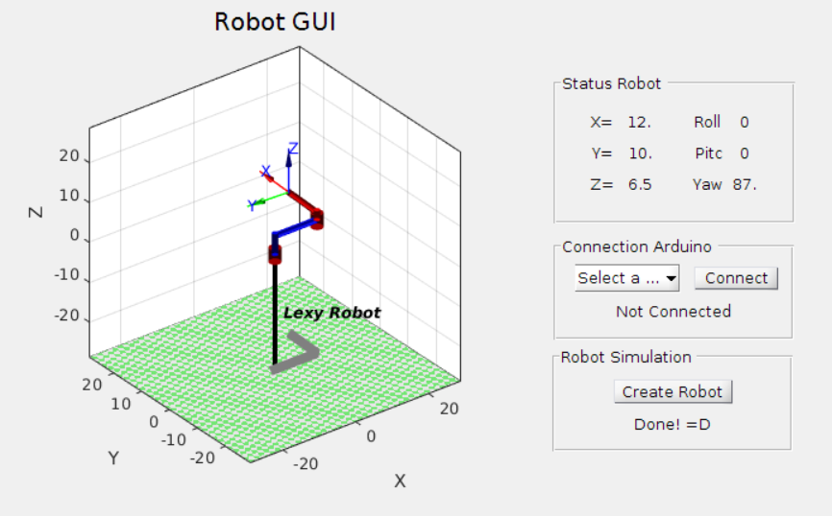

Bu şekilde komut girme ekranı çıkmaktadır.En son aşama olup ,bu süreçde verdiğimiz açılara göre robot kolu hareket etmektedir.

Bu aşamda matlam simulink veri dosyası da büyük yardımcı olmuş ve kullanılmıştır.